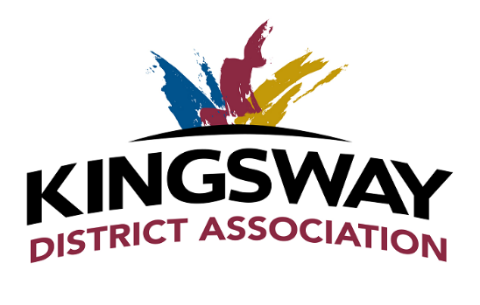
Go Green Award
Criteria:
• Any business or organization that has taken steps this year to reduce their environmental impact

I/We ___________________________________________ nominate ____________________________
Company or person making the nomination Company to be Nominated

This company has made an effort to go green and reduce their waste by (provide sample)
__________________________________________________________________________________________________________________________________________________________________________
_____________________________________________________________________________________

Date Nominated:______________________________
Signature:____________________________________

Office use only:
Nomination received by ___________________
Date:____________________

*Nomination forms must be received no later than September 1, 2017. Email:office@kingswaydistrict.ca or fax to 780-453-1025.

